44.6: a) The energy will be the proton rest energy, 938.3 MeV, corresponding to a
frequency of 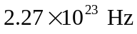 and a wavelength of 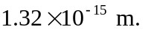 b) The energy of
each photon will be with frequency 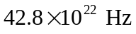
and wavelength 